**VISVESVARAYA TECHNOLOGICAL UNIVERSITY**

**Belagavi-590018**



**A Report on National Service Scheme (NSS)**

**BNSK359**

**Submitted by**

|  |  |
| --- | --- |
| **SAHANA** | **4SN23CS092** |

In partial fulfilment of the requirements for the Degree of

**BACHELOR OF ENGINEERING**

IN

**COMPUTER SCIENCE AND ENGINEERING**

|  |
| --- |
| Department NSS coordinator |
| **Prof. A Aishwariya**  Assistant Professor |



**Department of Computer Science and Engineering**

**SRINIVAS INSTITUTE OF TECHNOLOGY**

**MANGALURU-574143, KARNATAKA**

**2024-2025**

|  |  |  |  |  |  |  |  |  |  |  |  |  |  |  |  |  |  |  |  |  |  |  |  |  |  |  |  |  |  |  |  |  |  |  |  |  |  |  |  |  |  |  |  |  |  |  |  |  |  |  |  |  |  |  |  |  |  |  |  |  |  |  |  |  |  |  |  |  |  |  |  |  |  |  |  |  |  |  |  |  |  |  |  |  |  |  |  |  |  |  |  |  |  |  |  |  |  |  |  |  |  |  |  |  |  |  |  |  |  |  |  |  |  |  |  |  |  |  |  |  |  |  |  |  |  |  |
| --- | --- | --- | --- | --- | --- | --- | --- | --- | --- | --- | --- | --- | --- | --- | --- | --- | --- | --- | --- | --- | --- | --- | --- | --- | --- | --- | --- | --- | --- | --- | --- | --- | --- | --- | --- | --- | --- | --- | --- | --- | --- | --- | --- | --- | --- | --- | --- | --- | --- | --- | --- | --- | --- | --- | --- | --- | --- | --- | --- | --- | --- | --- | --- | --- | --- | --- | --- | --- | --- | --- | --- | --- | --- | --- | --- | --- | --- | --- | --- | --- | --- | --- | --- | --- | --- | --- | --- | --- | --- | --- | --- | --- | --- | --- | --- | --- | --- | --- | --- | --- | --- | --- | --- | --- | --- | --- | --- | --- | --- | --- | --- | --- | --- | --- | --- | --- | --- | --- | --- | --- | --- | --- | --- | --- | --- | --- |
| |  |  |  |  |  |  |  |  |  | | --- | --- | --- | --- | --- | --- | --- | --- | --- | | **SRINIVAS INSTITUTE OF TECHNOLOGY**  **MANGALURU - 574 143, KARNATAKA** | | | | | | | | | |  | | | | | | | | | | **DEPARTMENT OF COMPUTER SCIENCE AND ENGINEERING** | | | | | | | | | |  | | |  | | |  | | | | **CERTIFICATE** | | | | | | | | | | It is to certify that the report on National Service Schemecarried out at  **Srinivas Institute of Technology Mangaluru**  is a bonafide work carried out by | | | | | | | | | |  | **SAHANA** | | | | **4SN23CS092** | | |  | |  |  | | | |  | | |  | | In partial fulfilment for the award of **Bachelor of Engineering** in Computer Science and Engineering of the **Visvesvaraya Technological University, Belagavi** during the year 2023-24. It is certified that all corrections/suggestions indicated for Internal Assessment have been incorporated in the report deposited in the Departmental library. The NSS report has been approved as it satisfies the academic requirements in respect of National Service Scheme prescribed for the Bachelor of Engineering Degree. | | | | | | | | | |  | | | | | | | | | | **Prof. A Aishwariya** | | **Prof. Suresha D** | | | | | **Dr.Shrinivasa Mayya D** | | | **Department NSS Coordinator** | | **HOD** | | | | | **Principal** | | |  | | | |  | | |  | | |  | | | | CONTENTS | | |  | | |

|  |  |  |
| --- | --- | --- |
| Chapter No. | Headings | Page No. |
| 1 | Introduction | 2-3 |
| 2 | Methodology | 4-6 |
| 3 | Inference and Observation | 7 |
| 4 | Conclusion | 8 |
| 5 | Geo Tagged Photos | 9 |

**ACKNOWLEDGMENT**

The satisfaction that accompanies the successful completion of any work would be incomplete without thanking the persons who made it perfect with their constant guidance and encouragement.

I would like to extend my deepest gratitude and heartfelt acknowledgment to our NSS Coordinator Prof. A Aishwariya Assistant Professor, Department of CS&E, for her encouragement and timely advice provided to us during the NSS work.

I extend my warm gratitude to Prof. Head of the Department, Department of Computer Science and Engineering, for his constant support and advice that helped us to complete this NSS work successfully.

I extremely grateful to our beloved Principal, Dr. Shrinivasa Mayya D for his encouragement to come up with new ideas and advice to express them in a systematic manner.

I also like to thank all teaching and non-teaching staff of Srinivas Institute of Technology, Mangaluru for their kind cooperation during the course of the work.

Finally, I am extremely thankful to my family and friends who helped me in my work and made the project a successful one.

Student Name: Sahana

USN: 4SN23CS092

CHAPTER-1

**INTRODUCTION**

Waste management is the process of collecting, treating, and disposing of waste materials generated by human activities. It aims to reduce the harmful effects of waste on the environment and human health while promoting sustainability. Proper waste management prevents pollution of air, water, and soil, mitigates climate change by reducing greenhouse gas emissions, and conserves natural resources through recycling and reuse. As global waste generation increases due to urbanization and industrialization, adopting effective waste management practices is essential for ensuring public health, environmental protection, and sustainable development.

* 1. **What are the challenges faced?**
     1. **Inadequate Infrastructure**:

Many regions lack the necessary facilities for waste collection, sorting, and recycling. This results in improper disposal and pollution. Developing efficient waste management infrastructure requires significant investment.

* + 1. **Public Awareness and Participation**:

Public participation in waste segregation and recycling is often limited. Many people are unaware of the environmental impact of improper waste disposal. Educational campaigns and incentives are needed to encourage responsible waste practices.

* + 1. **Limited Recycling Capabilities**:

A large portion of waste generated is not recyclable due to a lack of technology or suitable facilities. This leads to high levels of landfill usage and environmental harm. Expanding recycling infrastructure can reduce waste sent to landfills.

* + 1. **Waste Generation Volume**:

The increasing volume of waste, especially in urban areas, puts immense pressure on existing waste management systems. Managing this growing waste load can overwhelm local services and harm the environment. Population growth and consumption patterns exacerbate the issue.

* + 1. **E-waste Management**:

Disposing of electronic waste is challenging due to the toxic materials they contain. Improper disposal can lead to environmental contamination and health risks. Specialized e-waste recycling is necessary but still underdeveloped in many areas.

* + 1. **Illegal Dumping**:

Despite regulations, illegal dumping of waste remains a significant issue. This contributes to pollution, health hazards, and environmental degradation. Stricter enforcement of laws and better waste disposal alternatives can mitigate this problem.

**1.1.7 Cost of Waste Management**:

Effective waste management requires significant funding for collection, processing, and disposal. In many areas, budget constraints hinder the implementation of sustainable practices. Investment in waste management infrastructure can be difficult due to competing priorities.

**1.1.8 Hazardous Waste Disposal**:

Managing hazardous waste, like chemicals or medical waste, poses significant safety and environmental risks. Improper disposal can lead to severe health and environmental consequences. Specialized treatment and disposal methods are required to safely manage these materials.

**1.1.9 Climate Change Impact**:

Waste management systems are often not designed to handle the increased frequency of extreme weather events. This can disrupt waste collection and cause landfill sites to overflow. Adaptation and resilience in waste management are needed to cope with climate-related challenges.

CHAPTER-2

**METHODOLOGY**

An effective waste management methodology requires a systematic and integrated approach that minimizes waste generation, maximizes resource recovery, and ensures environmentally responsible disposal of residual materials. This process begins with waste characterization, where the type, quantity, and composition of waste are analyzed. Through waste audits, data is gathered on sources of waste, such as households, industries, or commercial establishments. Understanding the nature of the waste generated enables tailored strategies to address specific challenges, such as managing hazardous materials or enhancing recyclability.

**2.1 Methodology for Waste Management**

1. The methodology for waste management begins with effective waste reduction strategies at the source. This involves minimizing waste generation through conscious consumption, reducing packaging, and adopting sustainable practices in both households and industries. Promoting waste segregation at the point of origin—such as separating recyclables, organic waste, and hazardous materials—helps ensure that waste is properly processed. Public education campaigns and awareness programs are vital in encouraging individuals to adopt waste reduction practices, making them a crucial first step in the waste management hierarchy.

2.Next, waste collection and transportation are key aspects of the waste management methodology. Efficient waste collection systems ensure that waste is regularly gathered and transported to appropriate treatment or disposal facilities. To improve efficiency, waste collection should be scheduled based on the volume of waste and the specific types of materials, ensuring that different waste streams are handled separately. Modern technologies, such as GPS tracking and real-time monitoring, can help optimize collection routes, reduce carbon footprints, and enhance the overall efficiency of the system.

3.After collection, the waste undergoes sorting and recycling at processing facilities. Materials such as paper, plastics, metals, and glass are separated, cleaned, and sent to recycling centers for reuse. Organic waste is often converted into compost or biogas through specialized facilities, contributing to sustainable agriculture and reducing the need for chemical fertilizers. However, not all waste can be recycled, and non-recyclable waste is either incinerated or sent to landfills. In the case of hazardous waste, special treatment processes ensure that harmful substances are neutralized or safely disposed of without affecting the environment.

4.Lastly, waste disposal, while minimized through reduction and recycling efforts, remains a part of the waste management process. Landfills and incineration plants are designed to manage non-recyclable and non-compostable waste. However, these methods must be carefully managed to minimize their environmental impact, such as methane emissions from landfills or air pollution from incinerators. In the future, innovations in waste-to-energy technologies and circular economy models offer promising solutions, reducing reliance on traditional disposal methods and contributing to more sustainable waste management practices. Continuous improvement in waste management strategies is essential for reducing waste, conserving resources, and protecting the environment.

**2.2 Public Involvement**  
The public plays a crucial role in waste management by practicing responsible disposal, segregating waste at the source, and participating in community-led initiatives. Awareness campaigns and educational programs can empower individuals to adopt sustainable waste management practices.

**2.3 Zero Wate Methodology**:

Key points of zero waste management:

1. **Waste Prevention and Reduction**: It encourages mindful purchasing decisions and promotes the use of durable, long-lasting goods.
2. **Reuse**: Encourages the repair, repurpose, and reuse of materials and products instead of discarding them.
3. **Recycling**: Promotes the separation and recycling of materials like paper, plastics, metals, and glass, ensuring that valuable resources are recovered and reused.
4. **Composting**: Organic waste, such as food scraps and yard waste, is composted to create nutrient-rich soil for gardening or agriculture.
5. **Design for Sustainability**: Advocates for the design of products and systems that prioritize durability, recyclability, and minimal environmental impact.

CHAPTER-3

**INFERENCE AND OBSERVATION**

Effective waste management significantly contributes to environmental protection by reducing pollution and conserving resources through recycling and composting. It also mitigates the negative impacts of waste, such as greenhouse gas emissions from landfills, and supports cleaner energy production through waste-to-energy technologies. Additionally, it promotes public health by minimizing the spread of diseases and hazardous exposure. Furthermore, waste management creates economic opportunities, fostering job growth and supporting the development of a sustainable, circular economy.

**3.1 Outcomes**

Effective waste management leads to numerous positive environmental and societal outcomes. By reducing pollution and preventing hazardous materials from contaminating the environment, it helps protect ecosystems and preserves natural resources. Proper waste segregation, recycling, and composting reduce the amount of waste sent to landfills, thereby conserving land and reducing harmful emissions, such as methane. Waste-to-energy systems further contribute by converting non-recyclable waste into usable energy, which helps reduce reliance on fossil fuels and supports cleaner energy production. Overall, these practices play a crucial role in combating climate change and minimizing the environmental impact of human activities.

In addition to environmental benefits, waste management has a significant positive impact on public health and the economy. Proper disposal and treatment of waste reduce health risks, such as waterborne diseases and respiratory issues, by preventing exposure to harmful chemicals and pathogens. The waste management industry also creates jobs in areas such as waste collection, recycling, and energy recovery, contributing to economic growth. Furthermore, effective waste management practices help improve the quality of life in communities by maintaining cleaner and safer environments. By promoting sustainable development and supporting the circular economy, waste management is key to creating a more sustainable and prosperous future for all.

**CONCLUSION**

Waste management plays a crucial role in ensuring environmental sustainability and public health. Effective waste management strategies, such as recycling, composting, and proper disposal, help reduce the burden on landfills and conserve natural resources. By minimizing waste and adopting eco-friendly practices, communities can lower greenhouse gas emissions and combat climate change. Governments, industries, and individuals must work together to implement policies and technologies that promote efficient waste handling. Ultimately, waste management is not just a responsibility but a necessity for creating a cleaner and healthier planet.

On a broader scale, investing in innovative waste management solutions can drive economic growth and job creation. Modern technologies like waste-to-energy systems and advanced sorting facilities transform waste into valuable resources. Education and awareness campaigns are equally vital, encouraging citizens to take active roles in reducing and managing their waste. Despite challenges such as financial constraints and infrastructure gaps, collective efforts can overcome these barriers. A commitment to sustainable waste management ensures the preservation of ecosystems for future generations while addressing today's pressing environmental concerns.

**POSTER**

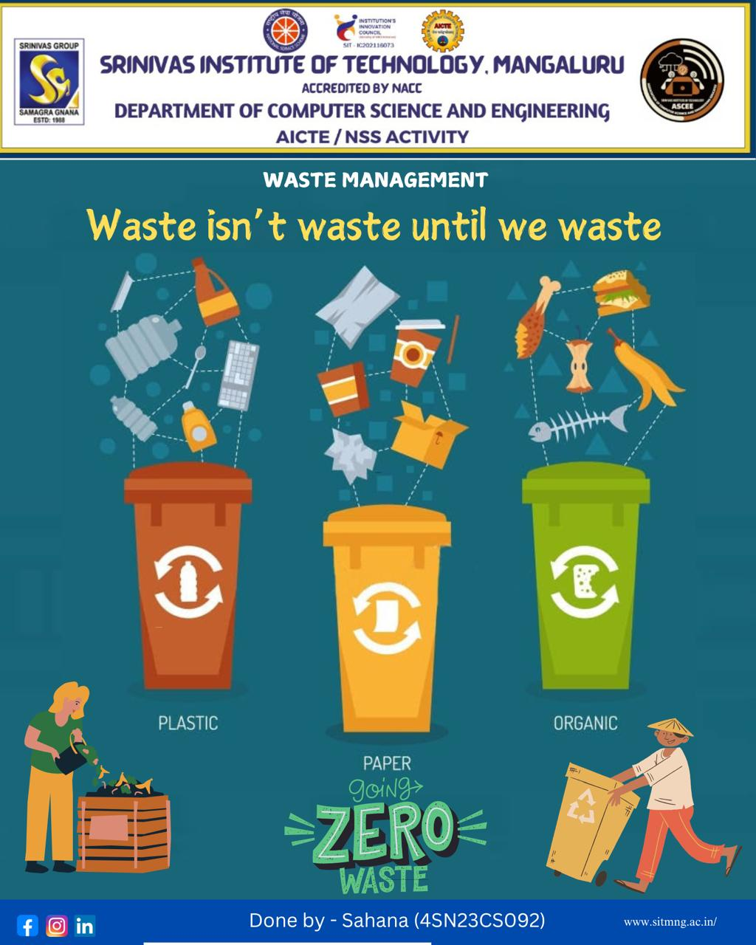

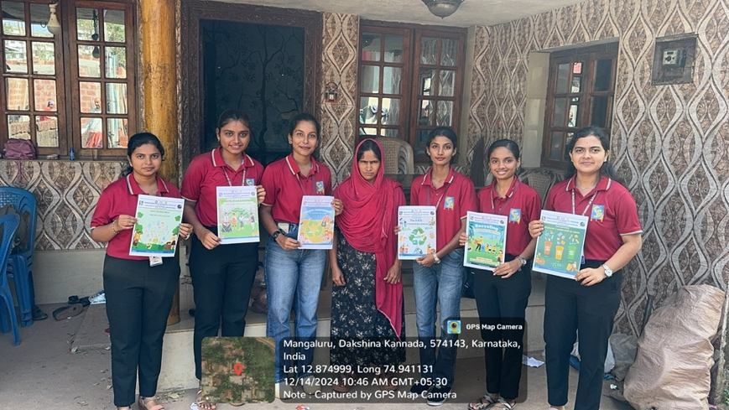**GEO TAG ACTIVITY PHOTOS**

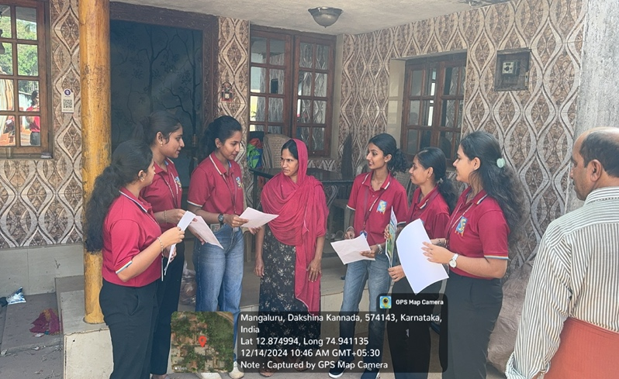

Visiting houses for activity

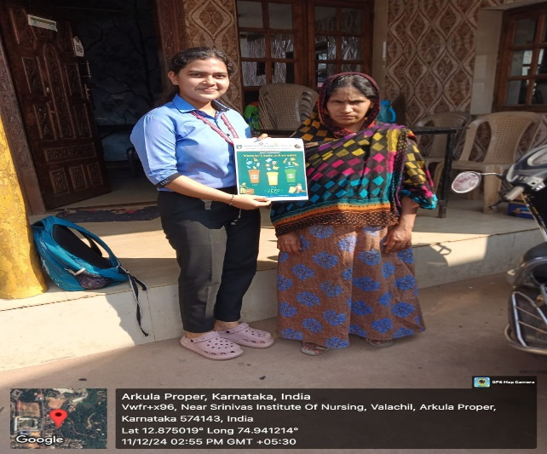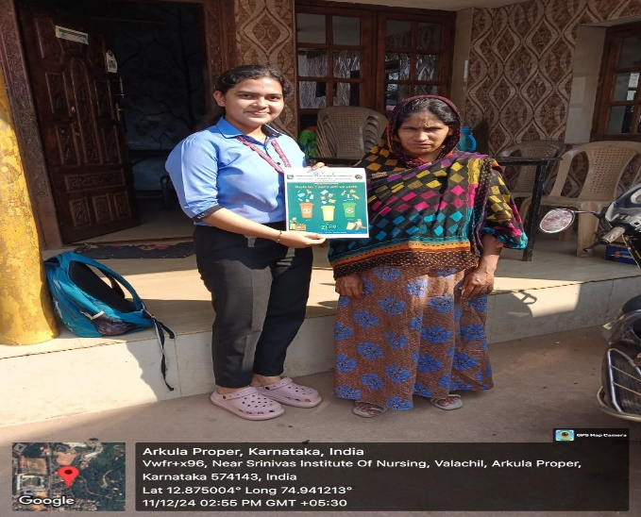

Visiting houses to give information